|  |
| --- |
| Name: _______________________________________________ |
|  |
|  |
|  |
|  |
| **Foundation Unit 9 topic test** |
|  |
| **Date:** |
|  |
|  |
|  |
|  |
| **Time:** 40 minutes |
|  |
| **Total marks available:** 34 |
|  |
| **Total marks achieved:** ______ |
|  |
|  |
|  |
|  |
|  |
|  |
|  |
|  |
|  |
|  |
|  |
|  |
|  |
|  |
|  |
|  |
|  |
|  |
|  |
|  |
|  |
|  |
|  |
|  |
|  |
|  |

**Questions**

**Q1.**

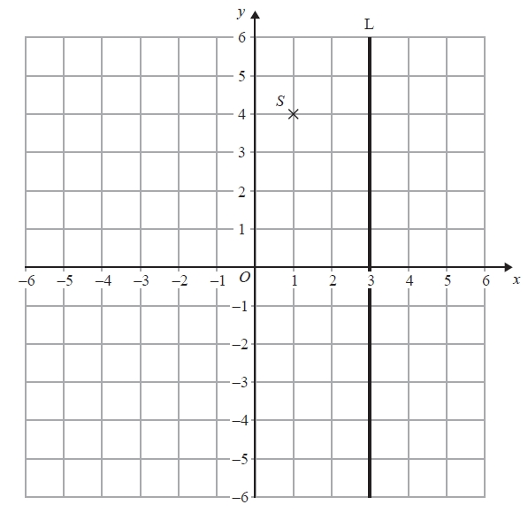

(a) Write down the coordinates of the point *S*.

(.............................. , ..............................)

**(1)**

The coordinates of the point *T* are (−3, 2).

(b) On the grid, mark this point with a cross (×).   
Label the point *T*.

**(1)**

(c) Write down an equation of the line L.

...........................................................

**(1)**

**(Total for Question is 3 marks)**

**Q2.**

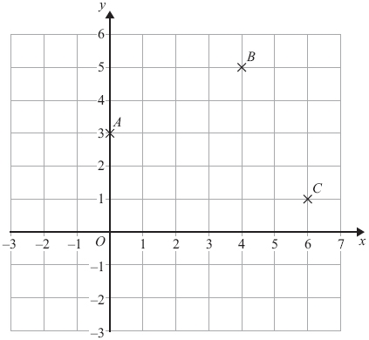

(a) Write down the coordinates of the point *B*.

..............................................................................................................................................

**(1)**

*A*, *B* and *C* are three corners of a square.

(b) On the grid, mark with a cross (×) the point *D* so that *ABCD* is a square.

**(1)**

**(Total for Question is 2 marks)**

**Q3.**

(a) Complete the table of values for *y* = 2*x* + 5

|  |  |  |  |  |  |
| --- | --- | --- | --- | --- | --- |
| *x* | –2 | –1 | 0 | 1 | 2 |
| *y* | 1 |  | 5 |  |  |

**(2)**

(b) On the grid, draw the graph of *y* = 2*x* + 5 for values of *x* from *x* = –2 to *x* = 2

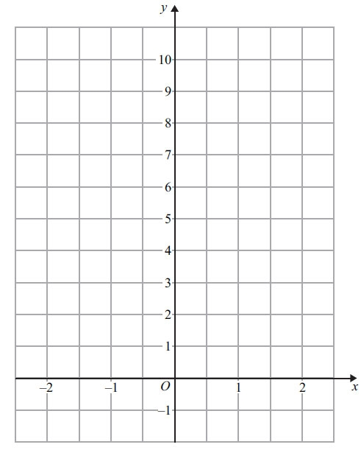

**(2)**

**(Total for Question is 4 marks)**

**Q4.**

The straight line **P** has been drawn on a grid.

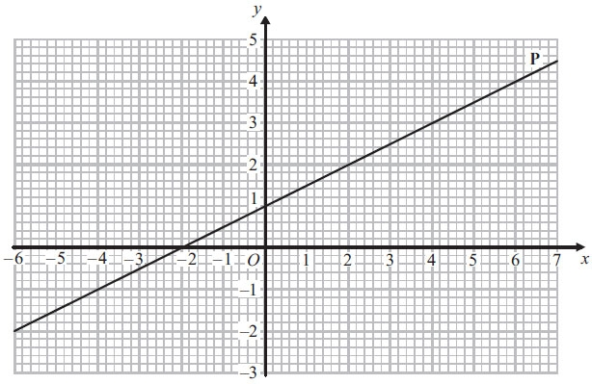

Find the gradient of the line **P**.

..............................................................................................................................................

**(Total for Question is 2 marks)**

**Q5.**

On the grid, draw the graph of *y* = 2*x* − 3 for values of *x* from −2 to 3

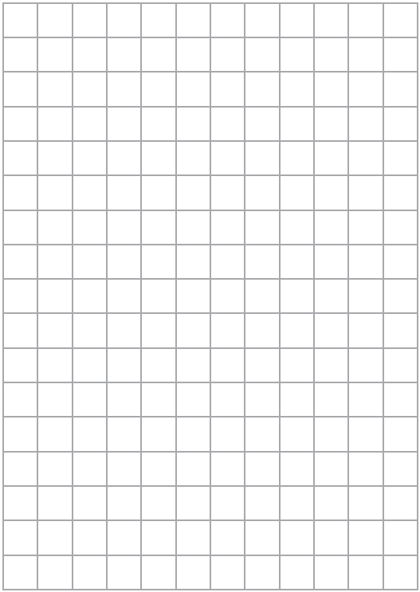

**(Total for Question is 4 marks)**

**Q6.**

Here are the graphs of 6 straight lines.

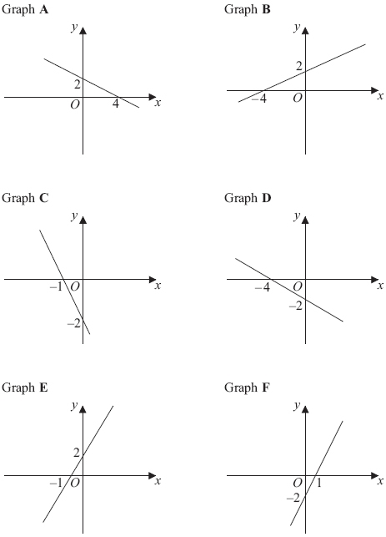

Match each of the graphs **A**, **B**, **C**, **D**, **E** and **F** to the equations in the table.

|  |  |  |  |  |  |  |
| --- | --- | --- | --- | --- | --- | --- |
| **Equation** | y = ½ *x* + 2 | y = 2*x* – 2 | y = – ½ *x* + 2 | y = – 2*x* – 2 | y = 2*x* + 2 | y = – ½ *x* – 2 |
| **Graph** |  |  |  |  |  |  |

**(Total for Question is 3 marks)**

**Q7.**

Anna drives 45 miles from her home to a meeting.

Here is the travel graph for Anna's journey to the meeting.

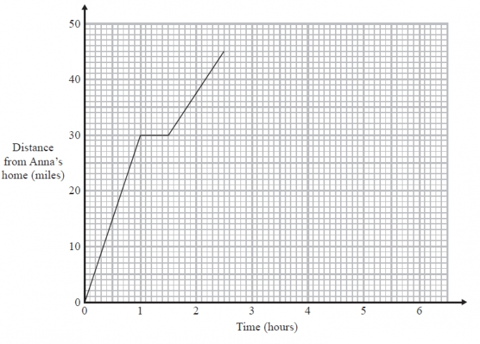

Anna's meeting lasts for 1 hour.   
She then drives home at a steady speed of 30 miles per hour with no stops.

Complete the travel graph to show this information.

**(Total for Question is 2 marks)**

**Q8.**On Monday, Holly walked from her home to school.  
She stopped at her friend's house on the way to school.

On Tuesday, Holly cycled from her home to school.

The travel graphs show Holly's journey on Monday and on Tuesday.

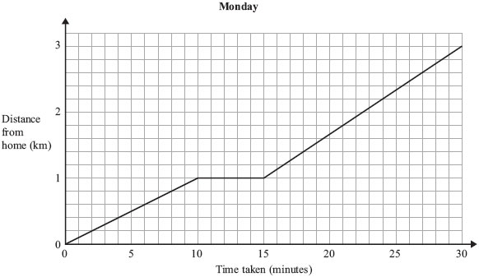

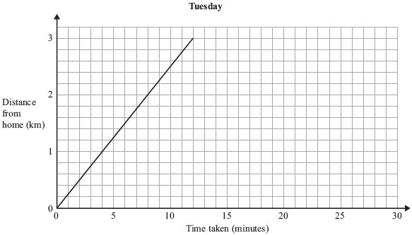

(a) Write down the distance from Holly's home to school.

. . . . . . . . . . . . . . . . . . . . . . km

**(1)**

(b) Write down how long Holly stopped at her friend's house on Monday.

. . . . . . . . . . . . . . . . . . . . . . minutes

**(1)**

Holly took less time to get to school on Tuesday than on Monday.

(c) How many minutes less?

. . . . . . . . . . . . . . . . . . . . . . minutes

**(2)**

**(Total for Question is 4 marks)**

**Q9.**

**\*** You can use this graph to change between miles and kilometres.

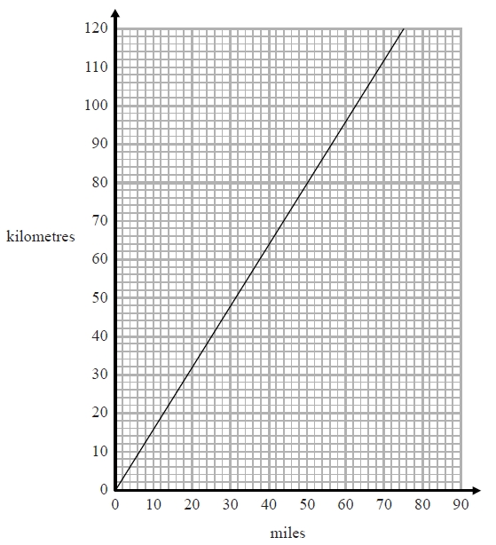

The distance from Paris to London is 280 miles.   
The distance from Paris to Amsterdam is 500 kilometres.

Is Paris further from London or further from Amsterdam?   
You must show how you get your answer.

**(Total for Question is 3 marks)**

**Q10.**

Josh changed some volumes measured in gallons to litres.

The table shows his results.

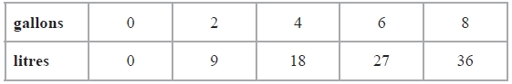

(a) On the grid, use this information to draw a line graph that can be used to change between gallons and litres.

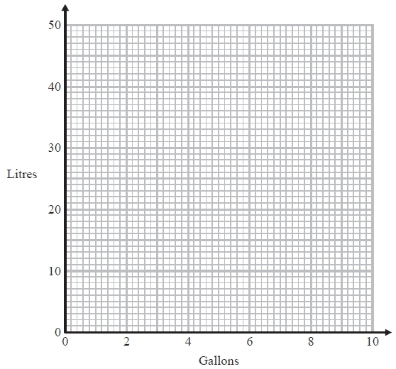

**(2)**

(b) Use your line graph to change 5 gallons to litres.

.........................litres

**(1)**

(c) Use your line graph to change 33 litres to gallons.

.........................gallons

**(1)**

**(Total for Question is 4 marks)**

**Q11.**

Sophie's company pays her 80p for each mile she travels.  
The graph can be used to work out how much her company pays her for travel.

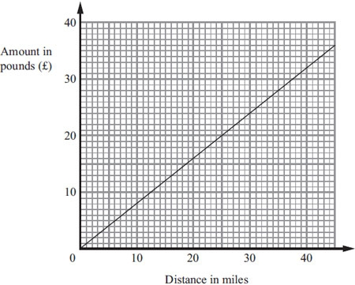

Sophie travels 20 miles.

(a) Work out how much her company pays her.

£ . . . . . . . . . . . . . . . . . . . .

**(1)**

Sophie's company paid her £60

(b) Work out the distance Sophie travelled.

. . . . . . . . . . . . . . . . . . . . . . miles

**(2)**

**(Total for Question is 3 marks)**

**Examiner's Report**

**Q1.**

Parts (a) and (b) in this question were well answered but when it came to giving the equation of the line, few candidates were able to write *x* = 3. Many gave two coordinates on the line and the usual incorrect response of *y* = 3 was the most common error seen in this part whilst in part (a) the point marked was often (−2, 3) or (−3, 2).

**Q2.**

Part (a) was a well answered question with the correct order of coordinates usually seen. In Part (b) the majority of candidates answered this correctly although many of them marked a cross rather than the letter D as requested. The most common wrong answer was (3, -1) followed by (0,2) and (0,3), all of which are one square away from the correct answer There were relatively few misunderstandings with x and y coordinates

**Q3.**

This question on straight line graphs was very well answered indeed with three quarters of candidates gaining all 4 marks.

Surprisingly, a significant number of candidates, despite constant reminders in previous reports, plotted correct points but did not join them up, scoring 3 marks.

It was a shame to see some candidates realise from part (b) that their points needed to be altered to form a straight line but then not go back to change their solution in part (a).

There were also some candidates who failed to realise that this was the equation of a straight line graph and drew a curved graph instead; many also made mistakes in completing the table by adding 5 to the *x* value, ignoring the need to multiply by 2.

**Q4.**

The most popular approach was to draw an appropriate triangle and then divide the relevant lengths. Many candidates were successful with this method, some did fail to get the final answer as they divided incorrectly, often giving the incorrect answer of 2 instead of 0.5. Another approach was to use two sets of coordinates and the formula, however more arithmetic errors crept into this method. Some candidates did find the gradient accurately but then gave the equation of the line as their answer, never isolating the gradient. This was seen as an embedded answer. Centres should encourage candidates to check they have clearly answered the question asked in the examination.

**Q5.**

Drawing and labelling a set of axes correctly was the main initial fault here, costing very many students the first mark. Axes needed to be correctly labelled *x* and *y* and linear scales including the origin. A number of L-shaped axes were seen, labelling as if in one quadrant from an "origin" of *y* = −7 and *x* = − 2. The most successful students showed a clear table of values with *x* and *y* clearly labelled ready to plot points easily. A number of students lost a final mark because they did not join their correctly plotted points together.

**Q6.**

This question was well attempted with most candidates filling all the boxes with a letter, however, only the most able achieved full marks. Candidates that achieved M1 usually got one of F, A, C or D correct. Weaker candidates used letters more than once.

**Q7.**

Travel graphs are usually well understood and this was the case here as far as the horizontal line was concerned but drawing a slant line of the correct gradient proved too difficult for most candidates.

**Q8.**

The first two parts of this question were almost always correct. Part (c) was also well done although there was some inaccurate reading of the graph. Providing candidates showed working then one mark could be awarded for a correct method if just one of the readings used was incorrect. However, many write down an answer alone so, in the event of the answer being incorrect, no mark could be awarded. In (c) a significant minority misread the second graph. Dropping a line from the end point to the horizontal axis usually led to a correct reading.

**Q9.**

Most students seemed to have the correct idea of what needed to be done to answer this question and many were successful. Errors that did occur were often as the result of misreading scales. A number of candidates converted both 280 miles and 500 km when only one was necessary and some then compared the wrong values. A few converted correctly and then came to the wrong conclusion or failed to give the units (km or miles) with their final answer, losing the final mark. The final statements were on the whole well written, although some students failed to get the last mark due to choosing London as further despite their figures telling them the opposite. There was a frequent misunderstanding of the scale, for example 40 miles = 60.2 km or 61 km.

**Q10.**

Part (a) was on the whole answered very well. Where students lost marks it was generally not due to inaccuracy when plotting, but just a lack of understanding of what they were being asked to plot with lines that did not extend to 0 or 8 gallons and responses showing bar charts or stick graphs seen.

Part (b) caused few difficulties but misreading of the horizontal scale in part (c) led to many answers of around 6.7 where one small square was interpreted as representing 0.1 rather than 0.2 gallons.

**Q11.**

For part (a) this question was answered correctly by the majority of candidates. The major mistake seen was the decimal point in the wrong place i.e. 1.60 or 1600. Quite a few did not use the graph; they multiplied 20 by 0.8 or 80. There were also a few who added 20 and 80 to get either 100 or 1  
 For part (b) most candidates attempted this question, with around half gaining full marks. Most of the candidates with the incorrect answers failed to gain the M1 mark because they showed no intention to multiply. The most common error was to read the scale on the graph incorrectly, mainly by inverting the £s and miles. Very few candidates showed the working of 60 ÷ 0.8

**Mark Scheme**

**Q1.**

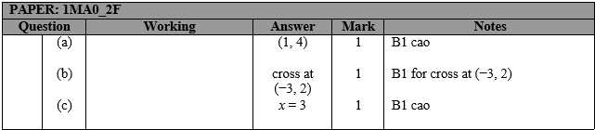

**Q2.**

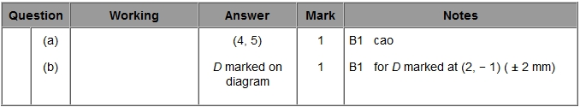

**Q3.**

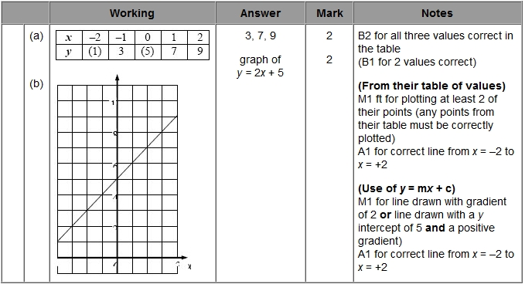

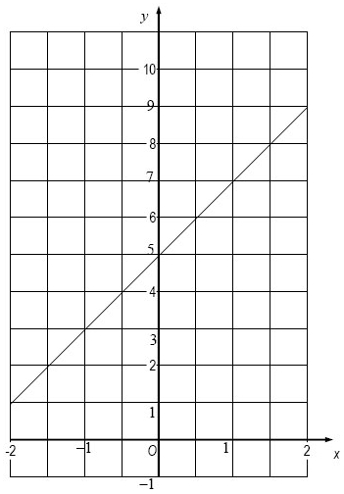

**Q4.**

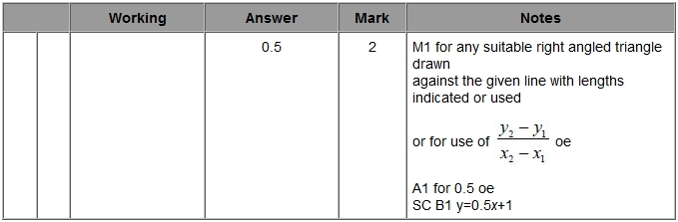

**Q5.**

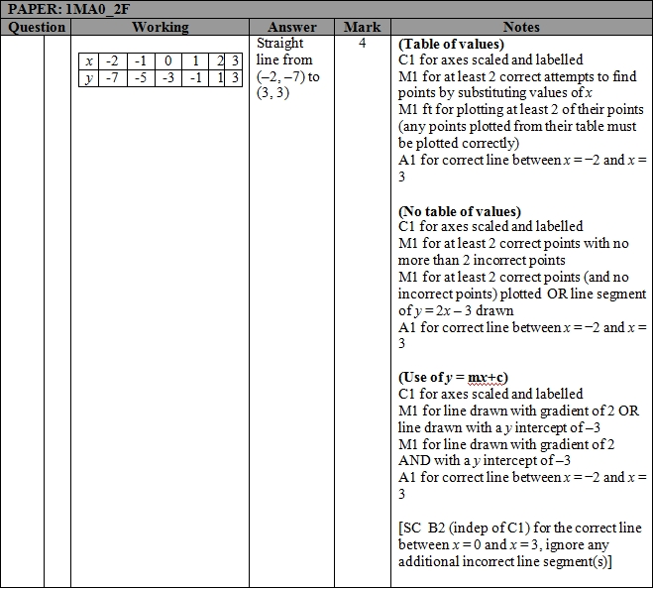

**Q6.**

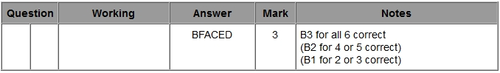

**Q7.**

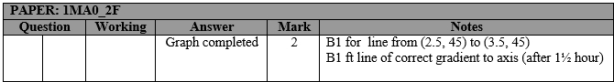

**Q8.**

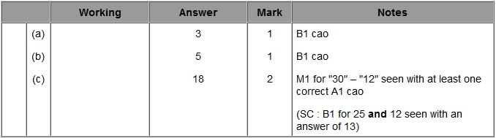

**Q9.**

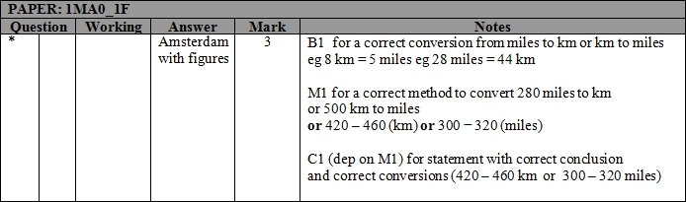

**Q10.**

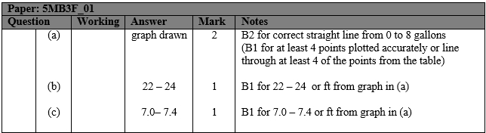

**Q11.**

