|  |
| --- |
| Name: _______________________________________________ |
|  |
|  |
|  |
|  |
| **Foundation Unit 11 topic test** |
|  |
| **Date:** |
|  |
|  |
|  |
|  |
| **Time:** 50 minutes |
|  |
| **Total marks available:** 46 |
|  |
| **Total marks achieved:** ______ |
|  |
|  |
|  |
|  |
|  |
|  |
|  |
|  |
|  |
|  |
|  |
|  |
|  |
|  |
|  |
|  |
|  |
|  |
|  |
|  |
|  |
|  |
|  |
|  |
|  |
|  |

**Questions**

**Q1.**

**\***    Talil is going to make some concrete mix.  
He needs to mix cement, sand and gravel in the ratio 1 : 3 : 5 by weight.

Talil wants to make 180 kg of concrete mix.

Talil has

15 kg of cement  
85 kg of sand  
100 kg of gravel

Does Talil have enough cement, sand and gravel to make the concrete mix?

**(Total for Question is 4 marks)**

**Q2.**

Liam, Sarah and Emily shared some money in the ratio 2 : 3 : 7   
Emily got £80 more than Liam.

How much money did Sarah get?

**(Total for question = 3 marks)**

**Q3.**

Here are the ingredients needed to make 10 pancakes.

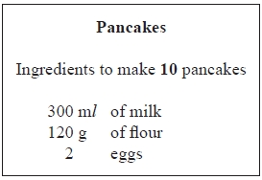

Matthew makes 30 pancakes.

(a)   Work out how much flour he uses.

........................................................... g

**(2)**

Tara makes some pancakes.   
She uses 750 m*l* of milk.

(b)   Work out how many pancakes she makes.

...........................................................

**(2)**

**(Total for Question is 4 marks)**

**Q4.**

Two companies, Barry's Bricks and Bricks ArUs, deliver bricks.  
The graph shows the delivery costs of bricks from both companies.

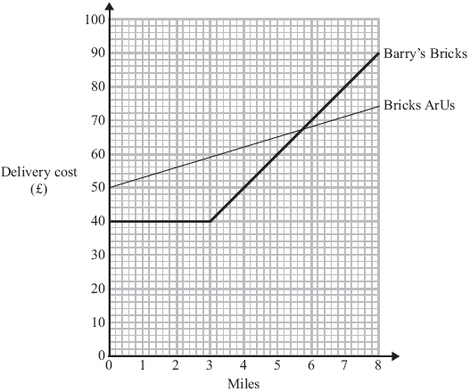

Prakash wants Bricks ArUs to deliver some bricks.  
He lives 2 miles away from Bricks ArUs.

(a) Write down the delivery cost.

..............................................................................................................................................

**(1)**

John needs to have some bricks delivered.  
He lives 4 miles from Barry's Bricks.  
He lives 5 miles from Bricks ArUs.

(b) Work out the difference between the two delivery costs.

..............................................................................................................................................

**(3)**

**(Total for Question is 4 marks)**

**Q5.**Colin, Dave and Emma share some money.

Colin gets 3⁄10 of the money.

Emma and Dave share the rest of the money in the ratio 3 : 2

What is Dave's share of the money?

      ..............................................................................................................................................

**(Total for Question is 4 marks)**

**Q6.**

In a company, the ratio of the number of men to the number of women is 3:2

40% of the men are under the age of 25   
10% of the women are under the age of 25

What percentage of all the people in the company are under the age of 25?

........................................................... %

**(Total for question = 4 marks)**

**Q7.**

Stephen is making soup.

He mixes one packet of soup with water to make 6 litres of soup.

Stephen has to make 90 bowls of soup.  
 He wants to put 0.2 litres of soup into each bowl.

How many packets of soup does Stephen need?

      ..............................................................................................................................................

**(Total for Question is 3 marks)**

**Q8.**

The cost of 3 calculators is £26.85

(a)  Work out the cost of 5 of these calculators.

**(2)**

The ratio of the number of boys to the number of girls in a class is 3 : 4

(b)  What fraction of the class is boys?

**(1)**

Shane and Gemma share 35 sweets in the ratio 1 : 4

Gemma eats 10 of her sweets and then gives Shane  of the sweets she has left.

(c)  How many sweets does Shane have now?

**(3)**

**(Total for question = 6 marks)**

**Q9.**

The total weight of 3 tins of beans and 4 jars of jam is 2080 g.   
The total weight of 5 tins of beans is 2000 g.

Work out the weight of 1 tin of beans and the weight of 1 jar of jam.

tin of beans ........................................................... g

jar of jam ........................................................... g

**(Total for question = 4 marks)**

**Q10.**

Orange squash is used to make orange drink.  
Jill is going to make orange drink for 50 people.

She is going to make 2 full glasses of orange drink for each person.  
She needs 250 millilitres of orange drink for each glass.

Here are the instructions for making orange drink.

|  |
| --- |
| Mix 1 part of orange squash with 4 parts of water. |

A one litre bottle of orange squash costs £2

Work out the total cost of the bottles of orange squash Jill needs to buy.

(1 litre = 1000 millilitres)

**(Total for Question is 5 marks)**

**Q11.**

Robert and his family are going on holiday to France.

A bank gives Robert this chart to help him to change between pounds (£) and euros (€).

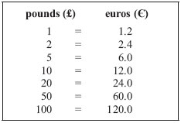

Robert changes £600 into euros (€).

(a) How many euros should Robert get?

      ..............................................................................................................................................

**(2)**

In France, a laptop costs €540   
In England, the same laptop costs £460

(b) Work out the difference between the cost of the laptop in France and the cost of the laptop in England.  
 You must show clearly how you got your answer.

..............................................................................................................................................

**(3)**

**(Total for Question is 5 marks)**

**Examiner's Report**

**Q1**

Candidates who realised the need to divide 180kg in the ratio 1:3:5 often succeeded in gaining at least 3 out of the 4 marks available. Often candidates would find the correct amounts required but then incorrectly compare them with the amounts already there. Many tried to divide 200 (15 + 85 + 100) in the given ratio. Others just thought that 200, being greater than 180, was sufficient.

Some candidates correctly found the sum of 15, 45 (3 × 15) and 75 (5 × 15) but were unable to correctly determine that more cement was needed.

Many weaker candidates chose the easier option of totalling the ingredients, gaining no credit.

**Q2.**No Examiner's Report available for this question

**Q3.**

Part (a) was answered successfully by the vast majority of students who appeared to identify the multiplier 3 and apply it with ease.

Part (b) proved more challenging although those that identified the correct multiplier 2.5 generally applied it to reach the correct answer. Many other students used a build-up method to reach 750 m*l* of milk. Some showed 300 = 10 pancakes, 600 = 20 pancakes and 150 = 5 pancakes but then combined all to give a final answer of 35 rather than 25.

**Q4.**

This question was answered quite well by candidates of all abilities. Over half of all candidates scored all four marks and only about 20% of candidates were unable to score any marks. The main error made by candidates in both parts of the question was to read off from the wrong graph. This error should surely have been detected if candidates had checked their working.

In part (b) a significant minority of candidates worked out the difference in the delivery costs for bricks delivered 5 miles from Barry's Bricks and bricks delivered 4 miles from Bricks ArUs. Again this error could have been avoided. Most candidates correctly interpreted the scales used on the axes.

**Q5.**

Few candidates made much progress with this question, though many were able to score at least one mark for 7⁄10 or 70%

The most successful candidates were those who started with an amount of money, usually £100. Many of these attempts resulted in an amount of money being given as the final answer rather than as a fraction of the initial amount.

A common error here was to confuse the shares for Emma and Dave.

**Q6.**No Examiner's Report available for this question

**Q7.**

This was a fairly well attempted question by candidates with only about a quarter of candidates failing to score. A few candidates were awarded just the first mark, generally for 90 × 0.2 and just over half the candidates scored all three marks. Many candidates divided 90 by 0.2, leading to an incorrect answer of 450.

**Results Plus: Examiner Tip**

Candidates should always check that their answers are realistic. For example, in this question, some candidates worked out 90 ÷ 0.2 = 450 and wrote this as the number of packets of soup needed to make 90 bowls of soup.

**Q8.**No Examiner's Report available for this question

**Q9.**No Examiner's Report available for this question

**Q10.**

Most candidates were able to score marks for using two full glasses, or attempting to find the total volume of drink for all people or changing to consistent units, but relatively few attempted to deal with the ratio. A common incorrect answer was £50. Many candidates were unable to do the calculations involving multiples of 10, eg 50 × 500 and 250 × 100 were often incorrectly calculated as 2500.

**Results Plus: Examiner Tip**

Candidates should be advised to state the reasons for their decisions, eg explain why 2500 ml has been rounded up to three bottles of orange squash.

**Q11.**

Most candidates were able to use the information in the table to change £600 to Euros in part (a), usually by calculating 6×120.

It was perhaps surprising that a significant number of candidates chose to do this calculation by long addition.

A common error in this approach was to forget to carry the 1 from the tens column to the hundreds column to arrive at an answer of 620. Another common incorrect answer here was 72000 (from 120×600).

In part (b) many candidates had difficulty working out the difference in the cost of the laptop in consistent units. The most common approach here was not to use a conversion factor of 1.2 from the table, but to build up a combination of values from the table.

By far the most common incorrect answer seen was 80, where candidates simple subtracted the given amounts without any attempt to change currency.

A significant number of candidates converted both costs into the other currency before doing the subtraction.

Some candidates, having obtained the correct difference in a consistent currency, put the wrong currency symbol with their answer, whilst others did not attempt to include a currency symbol at all.

**Mark Scheme**

**Q1.**

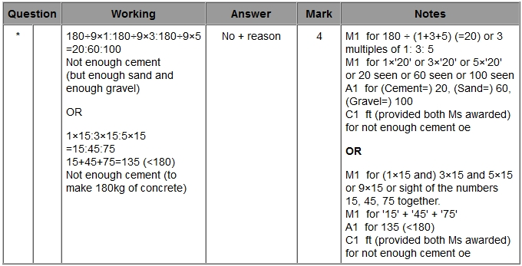

**Q2.**

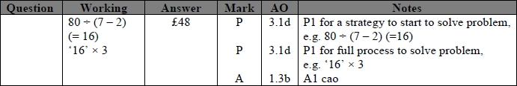

**Q3.**

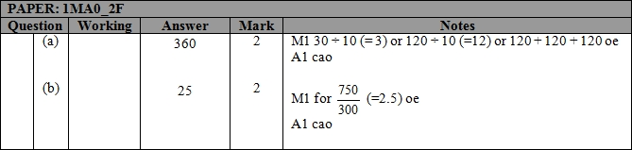

**Q4.**

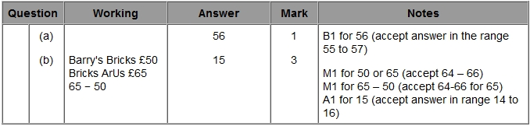

**Q5.**

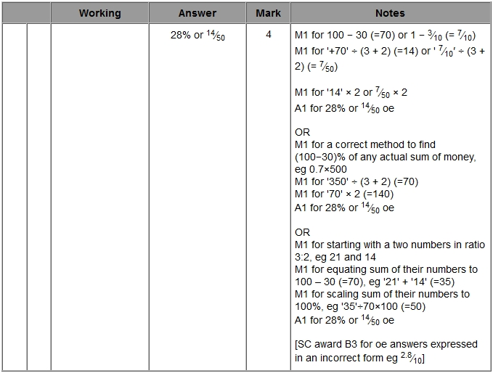

**Q6.**

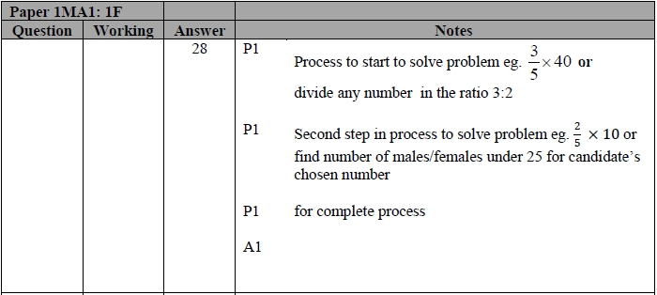

**Q7.**

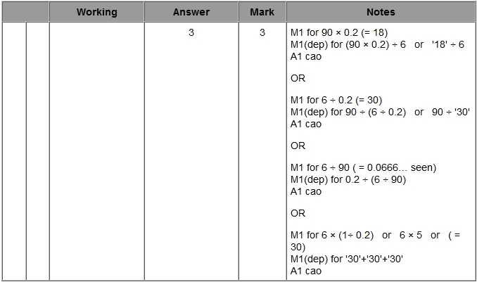

**Q8.**

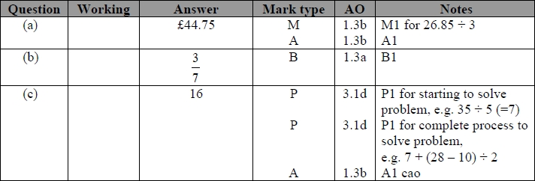

**Q9.**

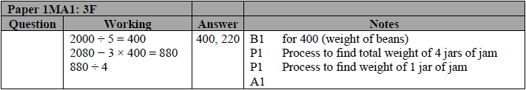

**Q10.**

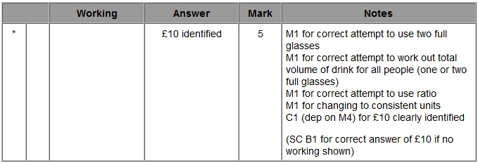

**Q11.**

